Density worksheet
Objectives
- What is density
- How do we measure density
- Measuring the densities of objects
- Why some things float and some things sink

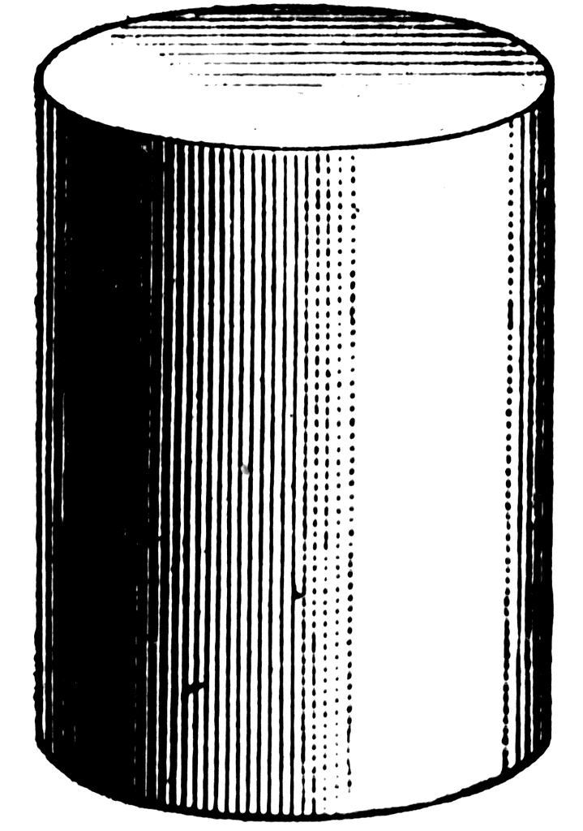
Look at the copper and aluminium blocks.
They both have the same mass (1kg)
Why does the aluminium block have a larger volume?
The atoms in aluminium are lighter than the atoms of copper, so the same mass of aluminium will contain more atoms than the same mass of copper.

Copper aluminium

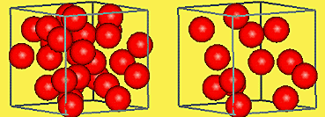
In which picture are the particles more densely packed?
The left.

Definition of density
Density is the mass per unit volume of a material. (The amount of stuff packed into a certain space)
Two ways that the densities of materials might be different:
1. the atoms of the different materials have different mass
2. the way the particles are arranged (more or less spread out)
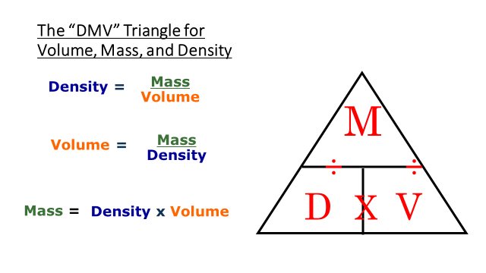
ρ
ρ = 
Mass is measured in kg
Volume is measured in m³
Density is measured in kg/m³

You must always remember to use the correct units!
To change from grams to kilograms
÷ 1 000

To change from cm³ to m³
÷ 1 000 000

Questions
A block of lead has a mass of 44000 kg and a volume of 4 m³ .
What is the density of lead?

Mass = 44000 kg
volume = 4 m³
Density = mass ÷ volume = 44000 ÷ 4 = 110000 kg/m³

An ‘empty’ bedroom measures 5m x 4m x 2.5m. If the density of air
is 1.3 kg/m³ what is the mass of air in the room?

Volume = 5 m x 4 m x 2.5 m = 50 m³
Density = 1.3 kg/m³
Mass = density x volume = 50 x 1.3 = 65 kg

A piece of anthracite has a volume of 15 cm³ and a mass of 27g.
What is its density in kg/m³ ?

Volume = 15 cm³ ÷ 1 000 000 = 0.000015 m³
Mass = 27 g ÷ 1000 = 0.027 kg
Density = mass ÷ volume = 0.027 ÷ 0.000015 = 1800 kg/m³

The resolution of a measuring instrument is the smallest scale markings on the instrument.

What is the resolution of the ruler in the picture? 1 mm

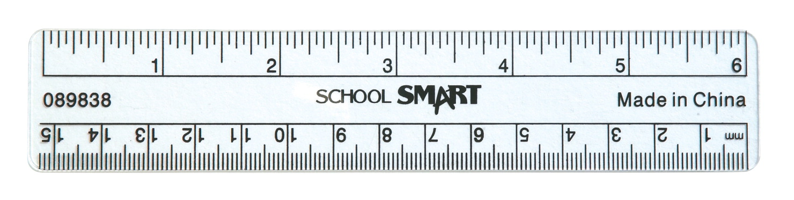

We are going to measure objects that are centimetres in length.
This means that using a ruler to make this measurement is appropriate as what we are trying to measure is much bigger than the resolution of the ruler.

What is the resolution of the balance in the picture? 0.01 g
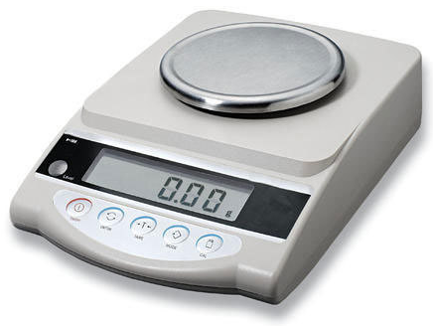
It is important to choose the right measuring instruments for the job.

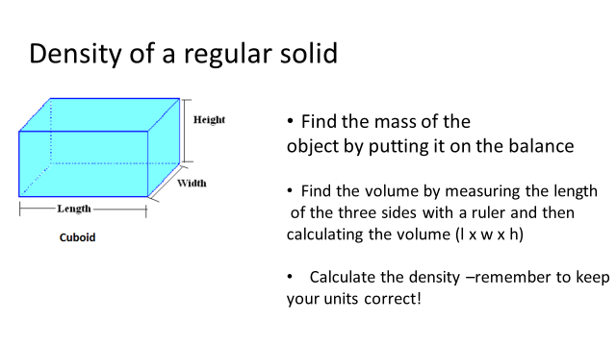
Practical work

Results
Length of block = ______ cm (divide by 100) = ___________ metres
Width of block = ______ cm ___________ metres
Height of block = ______ cm ___________ metres
Volume of block = _________ m³
Mass of block = ________ grams (divide by 1000) = _________kg
Density of block = mass ÷ volume
= _____________ kg/m³
What was the resolution of the ruler that you used?

Do you think that this was appropriate?

What was the resolution of the balance that you used? Was this appropriate?

Finding the density of a spherical ball bearing
Use the micrometre screw gauge to find the diameter of the ball bearing.
Find the mass of the ball bearing.

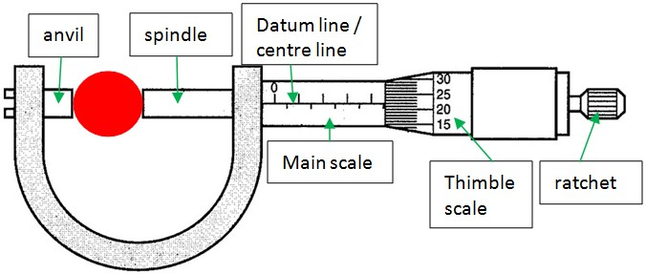

Diameter of ball bearing = __________ mm
convert to metres (÷1000) = __________m
Radius of ball bearing =diameter ÷2
= ___________m

Volume of a sphere
= _________m³
Mass of ball bearing = _________g
convert to kilograms (÷1000) = _________kg
Density of ball bearing = _________kg/m³

