**Leaf Cell**

Leaf cells are adapted for photosynthesis. They are responsible for making food for the plant. Leaf cells contain many chloroplasts (which contain chlorophyll) allowing them to absorb light energy from the sun. This light energy is converted into chemical energy and stored as glucose.

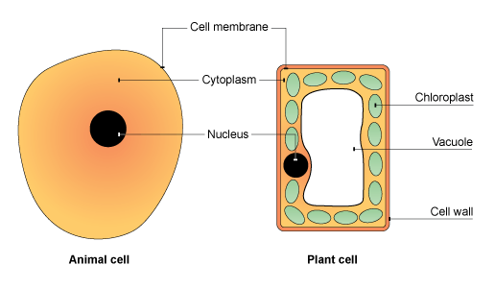

**Root Hair cell**

Root hair cells are located in roots of plants (and only look like hair). They are responsible for absorbing water and mineral nutrients from the soil.

Root hair cells are able to do this very efficiently because they contain a long, thin projection. This increases the surface area and speeds up absorption. The walls of root hair cells are also very thin so water and minerals more easily pass through.

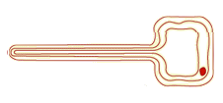

Root hair cells have no chloroplasts and do not carry out photosynthesis.

Can you think of why?

**Sperm Cell**

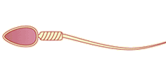

Sperm cells perform an essential function in human reproduction. Their job is to fertilise an egg cell to form an embryo. Sperm cells carry half of the genetic information of the new baby.

Sperm cells contain a tail that is used to swim towards the egg cell.

The head is packed with genetic information. It also contains a pointed head containing special enzymes to help to burrow into the egg during fertilisation.

The middle section of the sperm is also packed with mitochondria for energy.

They contain a special chemical called haemoglobin which allows it to carry oxygen.

The outer membrane is also very thin allowing oxygen to easily diffuse through.

The disc like shape increases the surface area to allow more oxygen to be absorbed efficiently.

Red blood cells are also the only animal cells without a nucleus. This is to make more room for haemoglobin to carry more oxygen

**Red Blood Cells**

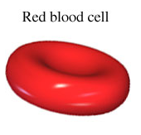

Red blood cells carry oxygen around the body. Oxygen is vital for respiration. Without it, cells wouldn’t have the energy they need for all life processes.

**Xylem Tissue**

Xylem cells are actually dead! They form a continuous tube of xylem tissue that works like a plumbing system.

They are just empty cells with no end walls. Only tough cell walls remain to form a hollow tube.

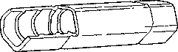

Xylem tissue is responsible for transporting water and providing support for the plant.

**Phloem Tissue**

Phloem works with xylem and transports nutrients (especially sugar) throughout the plant.

Phloem is made of living tissue. Phloem cells are connected end to end with holes in the end walls between cells. Phloem contains cytoplasm that is able to flow from one cell to the next through the holes.

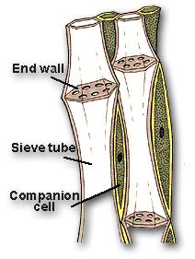

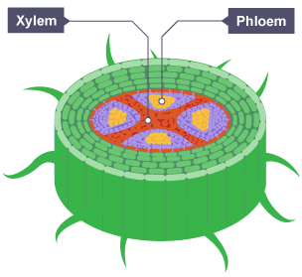

**Ciliated Epithelial Cell**

Ciliated epithelial cells have tiny hairs called cilia. They push and move mucus around. They are extremely important part of the respiratory system. The mucus traps bacteria, dirt, and dust and the ciliated epithelial cells sweep the mucus out of the trachea into the stomach where it is digested by the stomach.

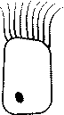

**Nerve Cell**

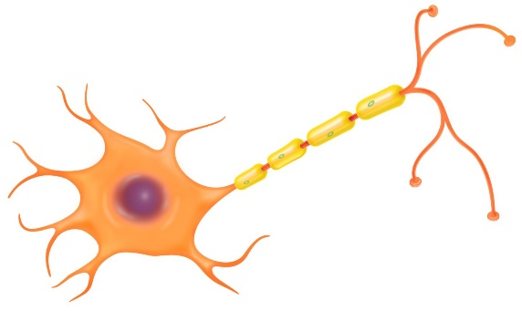

They are adapted to this function by being able to conduct electricity. They are also very long so they can carry the impulses over long distances.

They also have multiple connections on either end to communicate with multiple other nerve cells.

Nerve cells carry electrical signals called impulses around the body. This carries messages around the body.

**Muscle Cell**

Muscle cells are able to contract (stretch to become long and thin) and relax (return back to original shape). This allows the body to move.

They are elastic and able to change their shape in response to an electrical impulse.

