**Series Circuit** – only one pathway for electricity to take

If one bulbs breaks, all the bulbs go off because there is only one path to take.

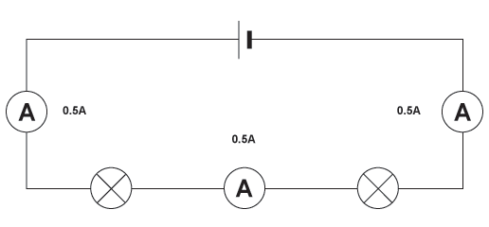

Current is the same everywhere in the circuit.

Adding more light bulbs decreases the current.

This is because light bulbs increase the resistance of the circuit.

The higher the resistance, the lower the current.

Adding more light bulbs makes the light bulbs dimmer.

This is because the energy (voltage) from the cell is divided between all the light bulbs. Example (diagram) Vs = V1 + V2 + V3

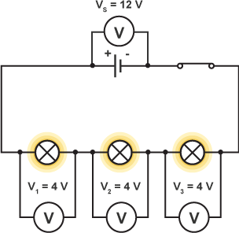

**Parallel Circuits** – multiple pathways for electricity to take

If one bulb breaks, the others stay on because the electricity still has a complete circuit path to take.

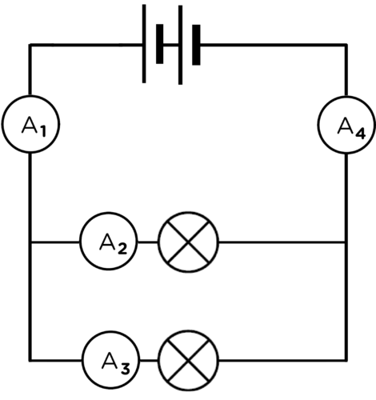

The current coming in and out of the cell is the sum of the current in the branches.

Example (diagram):

A1 = A4 = A2 + A3

Adding more light bulbs increases the current.

This is because the electricity has more pathways to take.

10 A

10 A

3 A

7 A

Adding more light bulbs does not change the brightness of the bulbs.

This is because the electrons do not have to share their energy (voltage).

Each bulb can be turned on and off with separate switches (switch is on the branch) or with one switch (switch next to the cell).

Example (diagram):

Switch 1 = turns off all bulbs

Switch 2 = only turns off bulb 1

Need to close switch 1 + 2 to turn on bulb 1.

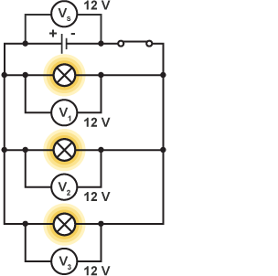

2

1

