GCSE Biology required practical activity: Enzymes

Student sheet

|  |  |
| --- | --- |
| **Required practical activity** | **Apparatus and techniques** |
| Investigate the effect of pH on the rate of reaction of amylase enzyme.  Students should use a continuous sampling technique to determine the time taken to completely digest a starch solution at a range of pH values. Iodine reagent is to be used to test for starch every 30 seconds.  Temperature must be controlled by use of a water bath or electric heater. | AT 1, AT 2, AT 5, AT 8 |

**Investigating the effect of pH on the enzyme amylase**

The enzyme amylase controls the breakdown of starch in our digestive system. We are able to simulate digestion using solutions of starch and amylase in test tubes. We can also determine the optimum conditions required.

The presence or absence of starch can be determined using iodine solution. In this experiment, **we can measure how long the amylase takes to break down the starch at different pHs.**

|  |
| --- |
| **Learning outcomes** |
| **1 Follow instructions to complete investigation safely and independently.**  **2 Record data on an appropriate results table.**  **3 Draw an appropriate graph of your results.** |

Risk assessment

* Safety goggles should be worn throughout.
* Take care with boiling water.

Method

**You are provided with the following:**

* test tubes
* a test tube rack
* water bath (electrical or Bunsen burner and beakers)
* spotting tiles
* 5cm3 measuring cylinder
* syringes
* a stop clock
* starch solution
* amylase solution
* buffered solutions covering a range of pH, each with a labelled syringe/plastic pipette
* iodine solution
* syringes.

**Read these instructions carefully before you start work.**

1. Place one drop of iodine solution into each depression on the spotting tile.
2. Place labelled test tubes containing the buffered pH solutions, amylase solution and starch solutions in the water bath. (This may have been done for you already.)
3. Allow the solutions to reach 30 °C.
4. Add 2cm3 of one of the buffered solutions to a test tube.
5. Use the syringe to place 2 cm3 of amylase into the buffered pH solution.
6. Use another syringe to add 2 cm3 of starch to the amylase/buffer solution.
7. Immediately start the stop clock and leave it on throughout the test.
8. Mix using a glass rod.
9. After 10 seconds, remove one drop of the mixture with a glass rod.

Place this drop on the first depression of the spotting tile with the iodine solution.

The iodine solution should turn blue-black.

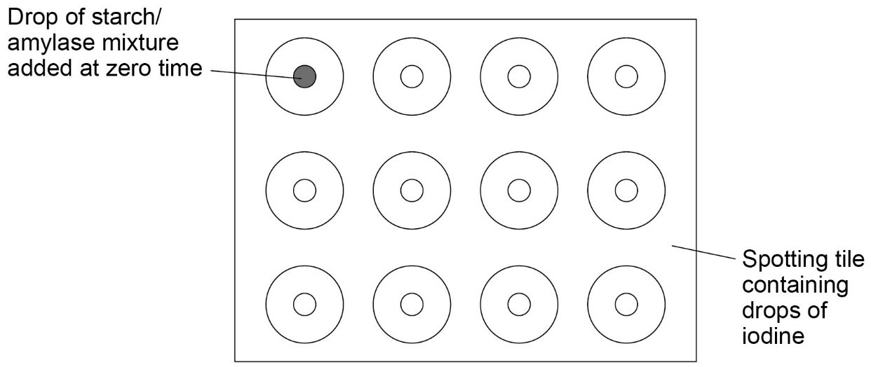

1. Use the glass rod to remove one drop of the mixture every 10 seconds. Put each drop onto the iodine solution in the **next** depression on the spotting tile.

**Rinse the glass rod with water after each drop.**

Continue until the iodine solution and the amylase/ buffer/ starch mixture remain orange.

1. Repeat the procedure with solutions of other pHs
2. Record the time taken for the amylase to completely break down the starch in an appropriate table.

1. Plot a graph. (HINT: independent variable on x-axis, dependent variable on y-axis).
2. Write a conclusion for your investigation. (HINT: remember to relate the independent variable to the dependent variable).