**Part of Cell:** Nucleus

Exists in both plant and animal cells.

**Function:** Control center of the cell

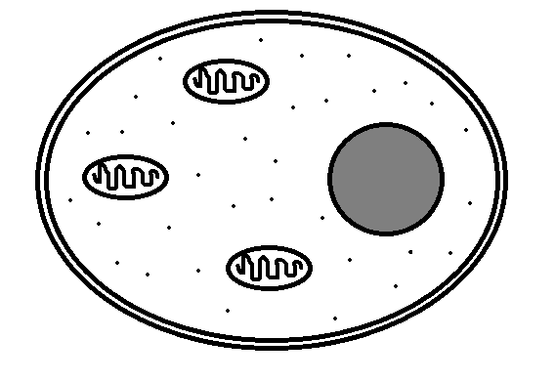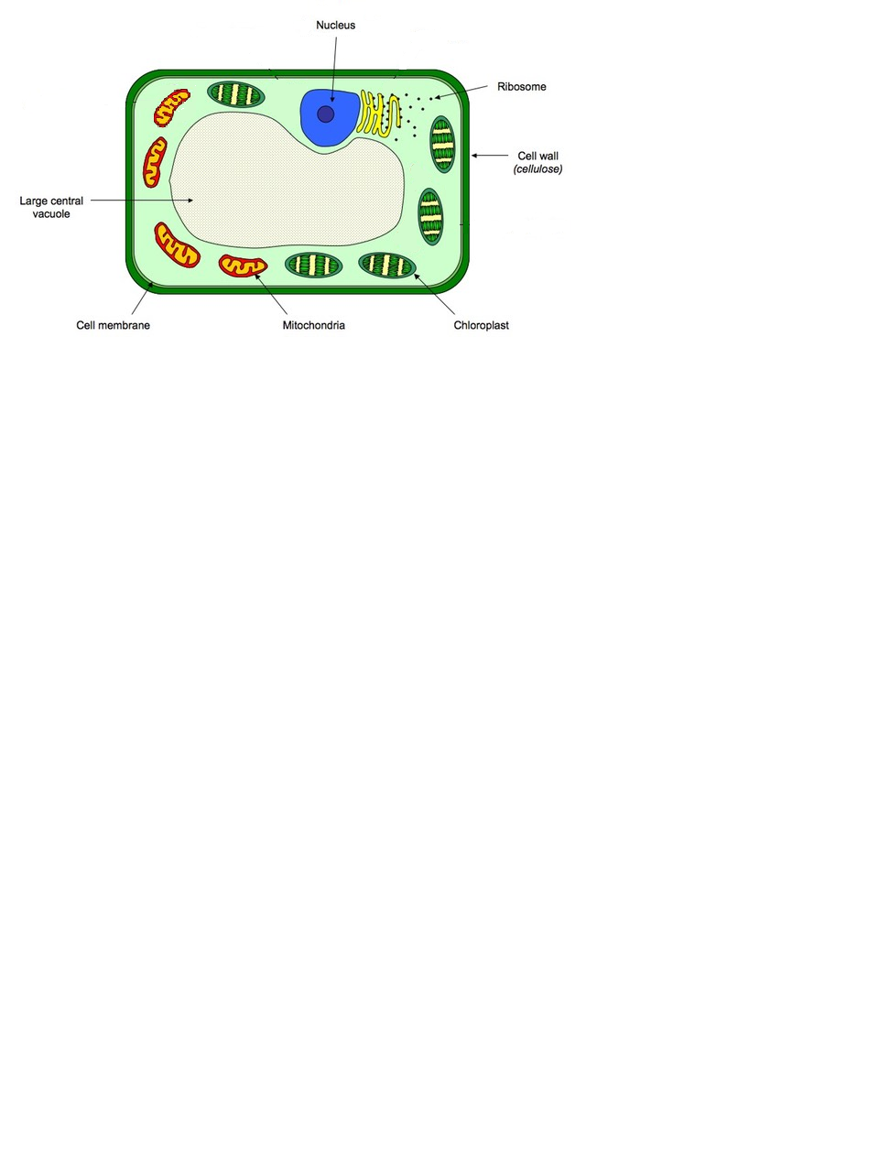

hgjhg

* Contains the genetic material of the organism as DNA.
* DNA coiled into structures called chromosomes and stored in the nucleus.
* DNA contains the instructions for all the products the cells needs to make and all the processes the cell needs to carry out.
* Also contains the genetic information that will be passed to new cells or offspring during reproduction.
* Bacterial cells (prokaryotic cells) do NOT contain a nucleus.

**Part of Cell:** Cell Membrane

Exists in plant, animal, and bacterial cells.

**Function:** Controls the passage of substances into and out of the cell



hgjhg

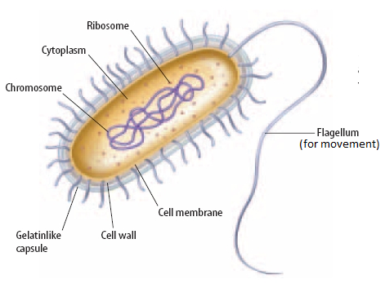

* All cells contain a cell membrane.
* The cell membrane is semi-permeable. This means that it lets some substances in and keeps others out.
* Useful substances, such as water and glucose, enter the cell.
* Waste products, such as carbon dioxide, leave the cell through the cell membrane.

**Part of Cell:** Cytoplasm

Exists in plant, animal, and bacterial cells.

**Function:** jelly-like substance where most of the chemical reactions occur



hgjhg



* All cells contain cytoplasm.
* Cytoplasm is a thick solution that fills each cell and is enclosed by the cell membrane.
* It is mainly composed of water, salts, and proteins.
* Most chemical processes take place here, controlled by enzymes.

**Part of Cell:** Mitochondria

Exists in plant and animal cells.

**Function:** aerobic respiration takes place here to release energy



hgjhg

* Aerobic respiration takes place in the mitochondria.
* Mitochondria are called the “power house” of the cell because this is where energy is released from glucose.
* Cells use this energy to carry out all their essential functions.
* Bacteria do not have mitochondria but still are able to respire for energy.

**Part of Cell:** Ribosome

Exists in plant, animal, and bacterial cells.

**Function:** makes proteins (protein synthesis)



hgjhg



* Ribosomes are where protein synthesis occurs (making proteins).
* Proteins are essential molecules and perform a wide variety of functions in the cell. They are used to make new cells, speed up chemical reactions (enzymes), act as hormones, and are an essential part of the immune system.

**Part of Cell:** Chloroplast

Exists in plant cells.

**Function:** makes glucose (food) for the plant through photosynthesis



hgjhg

* Chloroplasts contain chlorophyll.
* Chlorophyll is a green pigment that absorbs sunlight needed for photosynthesis and gives plants their green colour.
* Photosynthesis is a chemical reaction that forms glucose and oxygen from carbon dioxide and water.
* The glucose produced provides energy for the entire food chain.
* Energy (originally coming from the sun) is stored in the glucose molecules and released through respiration.
* Oxygen is an important by-product of photosynthesis that is essential for respiration.

**Part of Cell:** Vacuole

Exists in plant cells.

**Function:** is a storage space filled with cell sap to keep the cell’s shape



hgjhg

* The vacuole is often the largest part of the plant cell.
* It contains cell sap (mostly water) to help the plant cell retain the correct pressure and retain its shape.
* It also storage space containing different materials and waste.

**Part of Cell:** Cell Wall

Exists in plant and bacterial cells.

**Function:** a tough layer for protection and support



hgjhg

* The cell wall is an outer layer for protection.
* The cell wall also helps the cell to retain a rigid shape.
* Plant cell walls are made of cellulose which strengthens the cell.
* Bacterial cell walls are made of a different substance which is more flexible.

**Part of Cell:** Plasmid and Chromosomal DNA

Exists in bacterial cells.

**Function:** stores genetic material (DNA) in a single loop



Plasmid

hgjhg

* Bacterial cells DO NOT contain a nucleus.
* Instead genetic material (DNA) is stored as a single loop of DNA (chromosomal).
* Bacterial cells can also contain small loops of DNA called plasmids containing extra information.
* DNA contains all the instructions for all the products and processes of the cell.
* This genetic information is passed to offspring when the cell reproduces.