**Electricity**

Electrons – carry electrical energy around the circuit

Cell – gives energy to the electrons (“pushes” them around the circuit)

Wires – the electrons travel through the wires around the circuit

Light Bulb – electrons give the bulb energy and the bulb uses the energy to transfer to heat and light

Resistor – makes it more difficult for electricity to flow through (increases the resistance)

Current – a measure of how much electricity is flowing around the circuit (units = amps, A)

Voltage – a measure of how much energy the electrons have (units = volts, V)

**Model for Electricity**

Models can be used to help us understand a complicated idea. Here the postal service is a model for electricity.

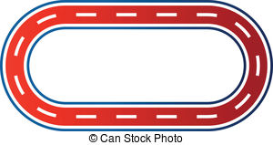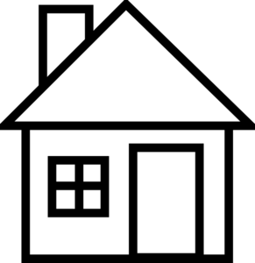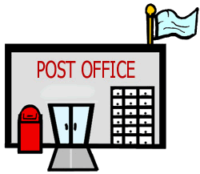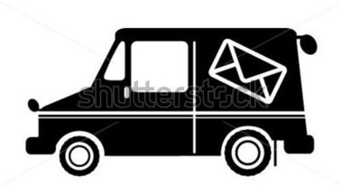

Electron = postman (delivers the energy/letters around the circuit)

Energy = letters (gets carried by electrons/postman around the circuit)

Cell = post office (gives the energy/letters to the electrons/postman)

Light Bulb = house (the electron/postman delivers the energy/letters here)

Resistor = speed bumps (makes it more difficult for the electricity/postmen to travel through)