1. Describe how to use a Bunsen burner safely.

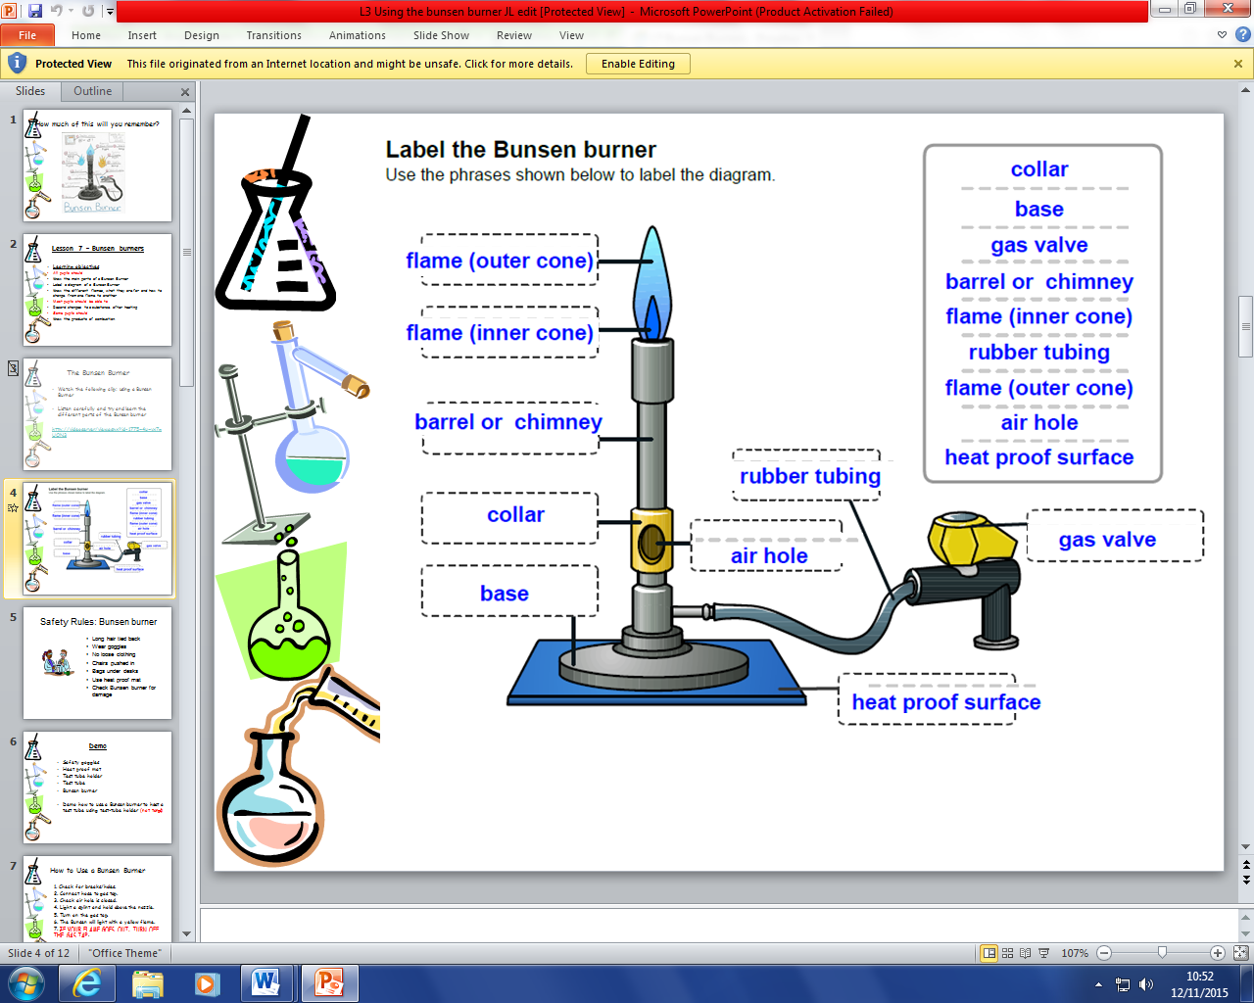

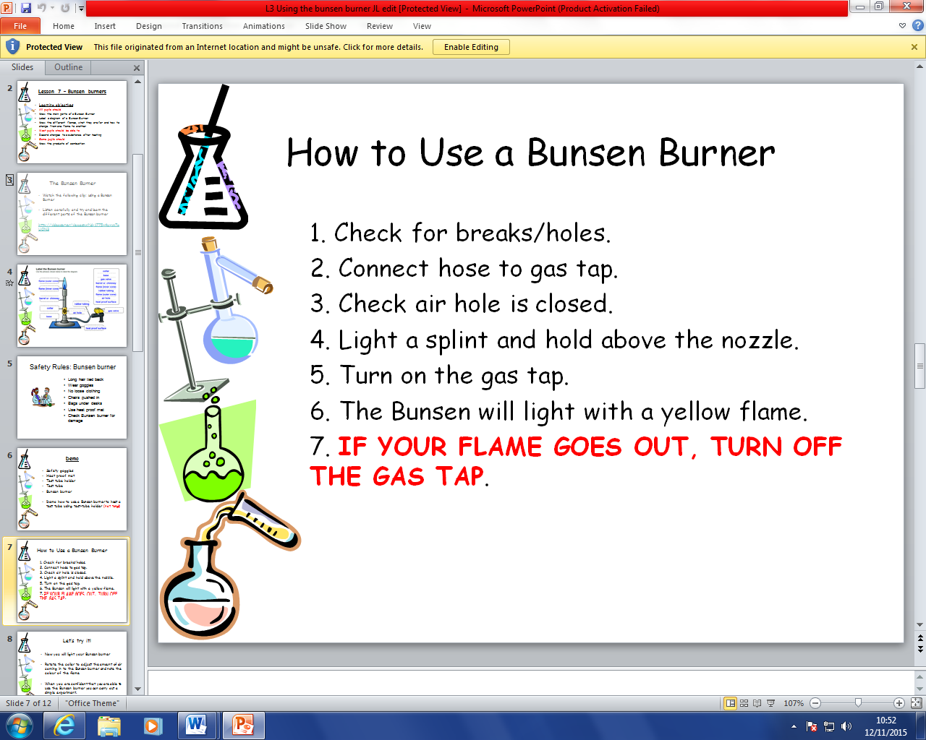

1. Recall the evidence of a chemical reaction.

Colour change

Gas formation

Energy given off (heat or light)

1. Explain the law of conservation of mass.

Matter cannot be created or destroyed in a chemical reaction.

Mass of Reactants (starting materials) = Mass or Products

1. Describe in terms of atoms what happens in a chemical reaction.

During a chemical reaction the atoms are rearranged.

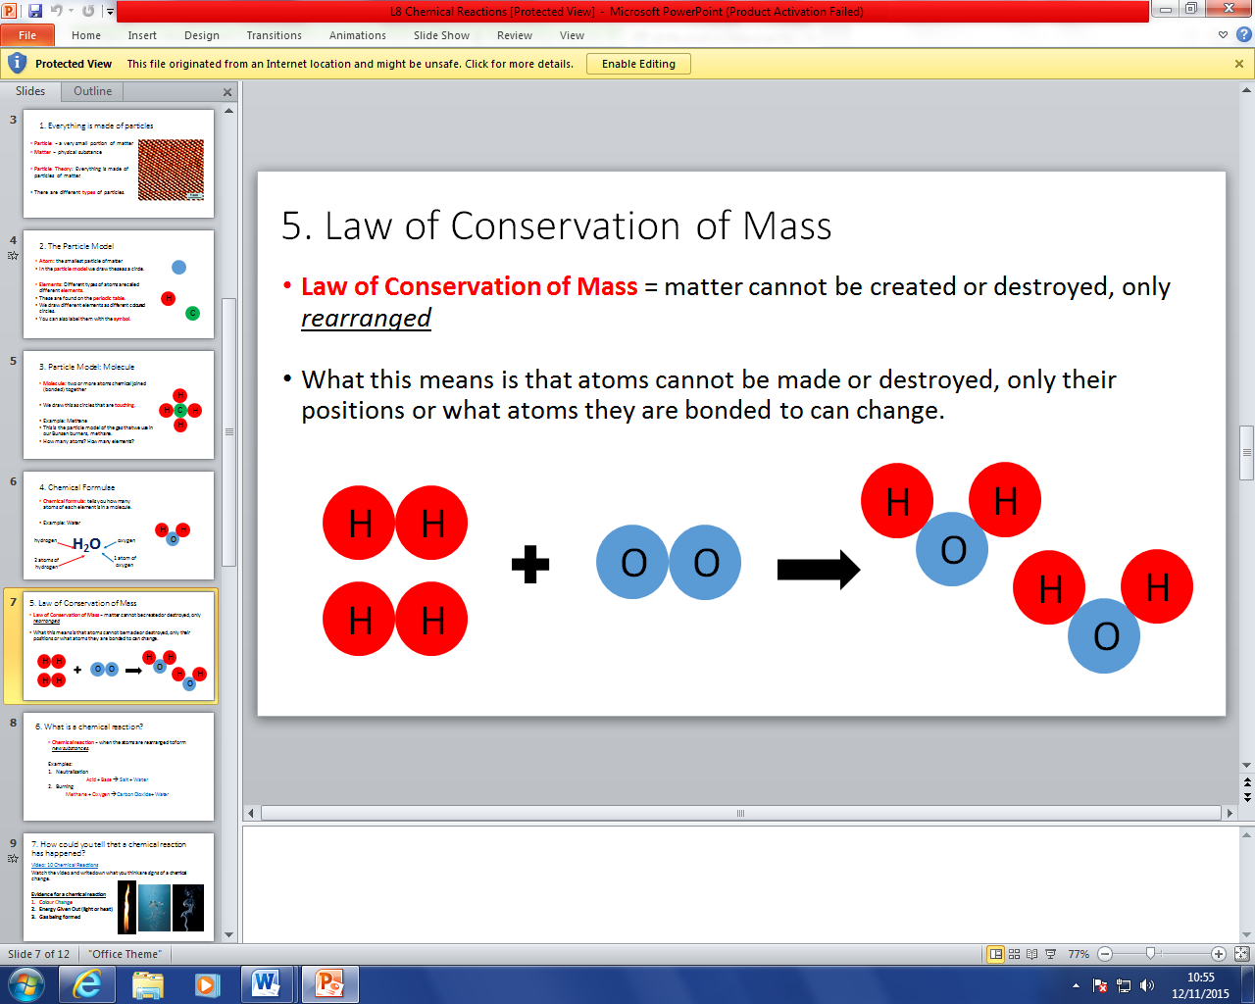

1. Give examples of chemical and physical changes.

Chemical Change = change where a new substance is formed

Examples: Combustion (burning), Neutralisation, Rusting

Physical Change = change where the substances stays the same

Examples: Mixing, Dissolving, Melting, Freezing

1. Describe what happens when metals react with acids.

When metals react with acid hydrogen gas and a salt are formed.

1. Describe the test for hydrogen.

Collect the gas.

Use a lit splint to ignite the gas.

If the gas burns with a squeaky pop the gas is hydrogen.

1. Describe what happens when carbonates react with acids.

When carbonates react with acids carbon dioxide gas, water, and a salt are formed.

1. Describe the test for carbon dioxide.

Bubble the gas through limewater. If the limewater turns milky/cloudy the gas is carbon dioxide.

1. Explain what is needed for a combustion reaction (fire triangle).

Combustion is the scientific name for the chemical reaction when substances burn.

Fire triangle: fuel, heat, and oxygen

1. Describe what a fuel is and what they are used for.

Fuels are chemical that store energy that can be released as heat and light energy through combustion.

Fuels are used to generate electricity in power stations, used for heating, and used for transportation (petrol for cars).

1. Extenstion: Write a word equation for metal + acid, metal + carbonates, and combustion reactions.

Metal + Acid 🡪 Salt + Hydrogen

Metal Carbonate + Acid 🡪 Salt + Carbon Dioxide + Water

1. Draw a graph. Line graphs are for continuous variables (numbers).

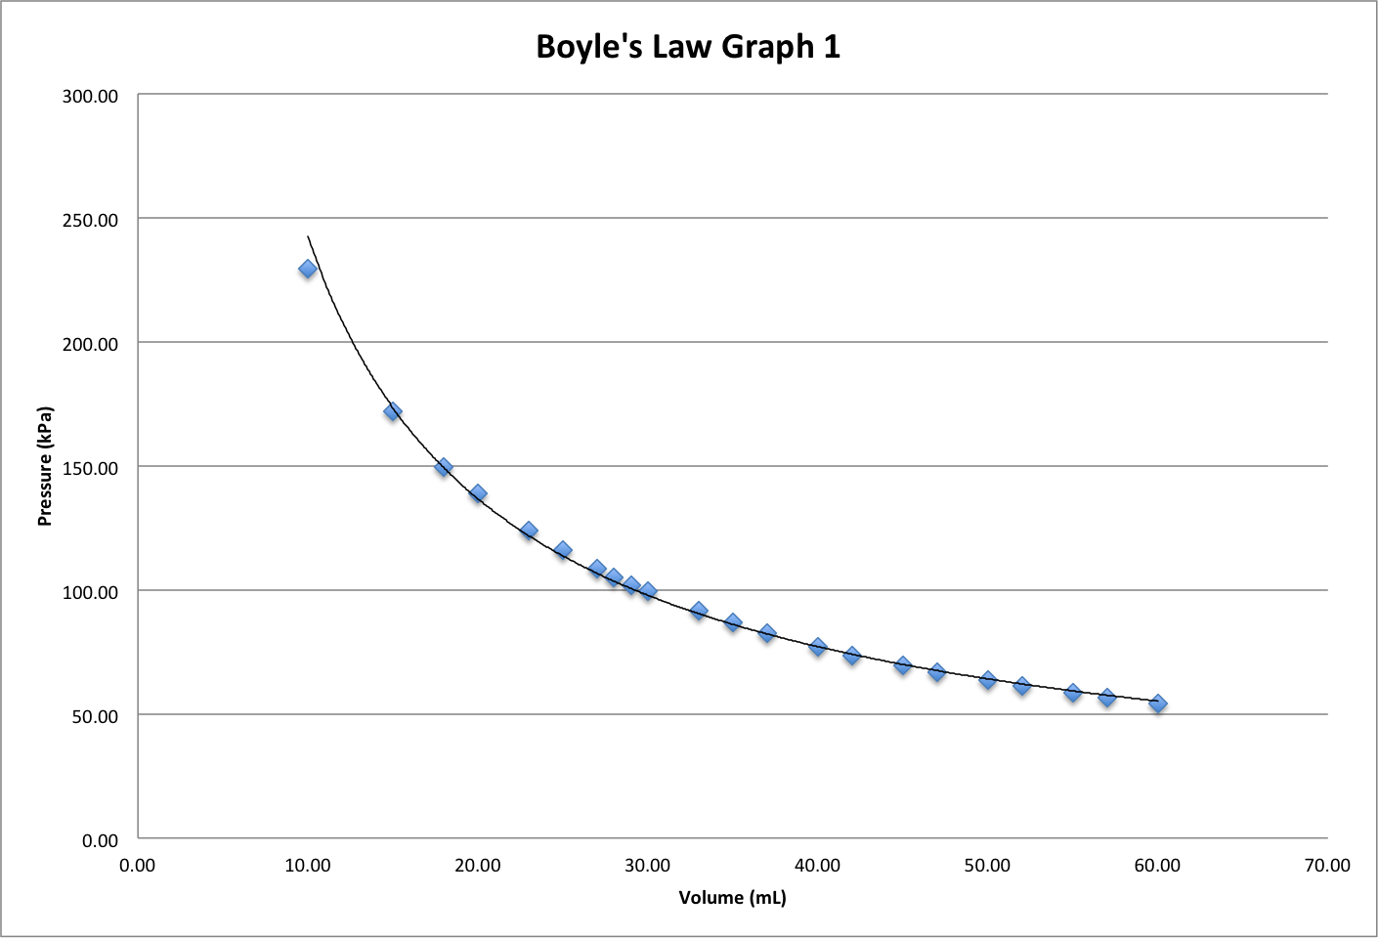

🡨 Labelled X-Axis with Units

(Independent Variable, we change)

🡨 Appropriate scale (try to fit graph to whole space)

🡨 Labelled Y-Axis with Units

(Dependent Variable, we measure)

🡨 Line/Curve of Best Fit

🡨 Title

Bar Graphs are for categorical variables (for categories without numbers).

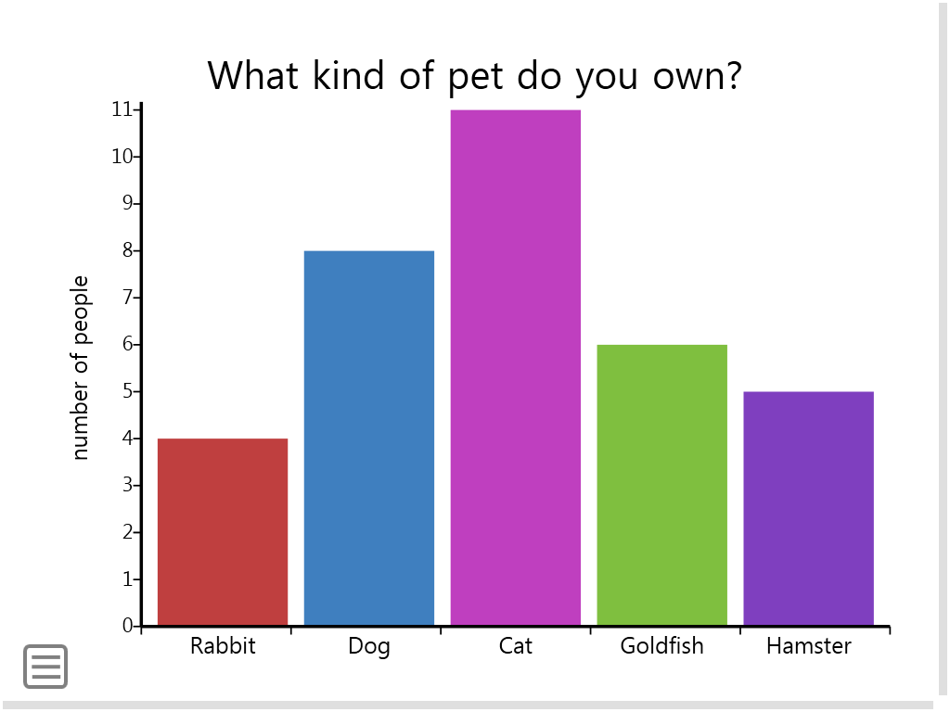

🡨 Labelled Y-Axis with Units

(Dependent Variable, we measure)

🡨 Appropriate scale (try to fit graph to whole space)

Labelled X-Axis with Categories

(Independent Variable, we change)

Leave a space between bars